Face Detection Algorithms –

1. Viola-Jones
2. Histogram of oriented gradients(HOG)
3. Convolutional Neural Network
4. Measuring Faces

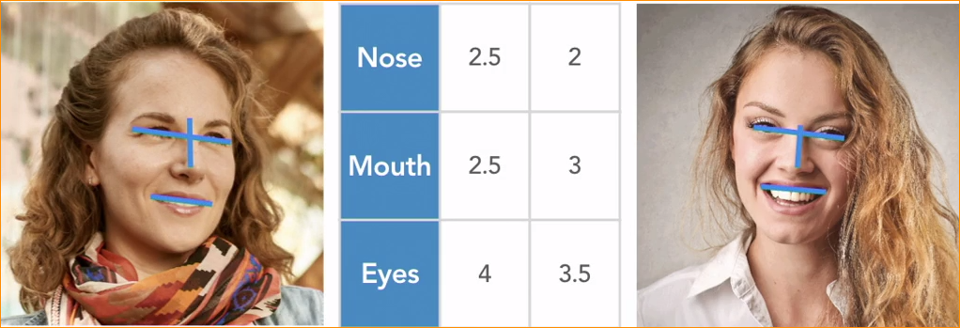

1. Cutting edge face recognition system
2. Using Projects

Face recognition is to look at the digital image of the human and recognize the person just by looking at the face.

Humans has built in ability to recognize the people. But in the computer it is difficult.

What can you Do with the Face Recognition ?

* To check whether a specific person you already know is present an image. This is call identify verification.
* To do this capture photograph of the person we want to recognize and use his photographs to train the face recognition system. So system can recognize that person again.
* This can use to user logging systems or key card entering systems.
* You can set up the camera at the entrance of the room, and each person walk pass the camera the system can recognize that person and play customized theme music for them as they pass by.
* Face recognition can use to quickly sort out through large collections of images.
* Tag famous peoples in the photography, tag friends you have as the example.
* Identify wanted people in to the police. Track people and moving cameara.

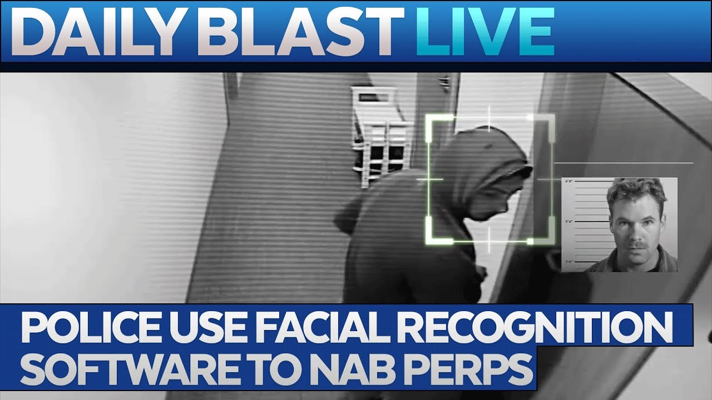

* Count the number of people. Taking count in exhibition or sign table.

Summary – **Use of face recognition**

1. Identify verification’
2. Automatically organizing new photo libraries by person.
3. Tracking a specific person
4. Counting unique people
5. Finding people with similar appearances.

**Tools for Face Recognition**

Several large vendors provide face recognition APIs that you can use over the internet for a small fee. They use different data set, so that accuracy may be change depending you application. Strong or weak.

World wise used Famous FR (Face Recognition API)

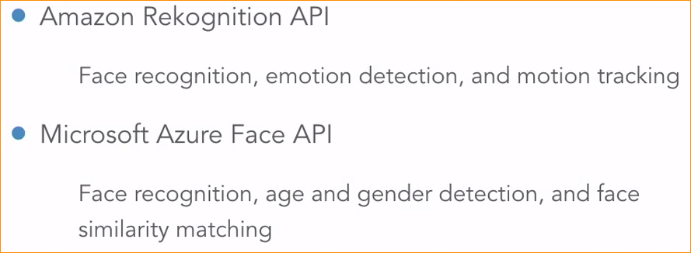

Amazon -

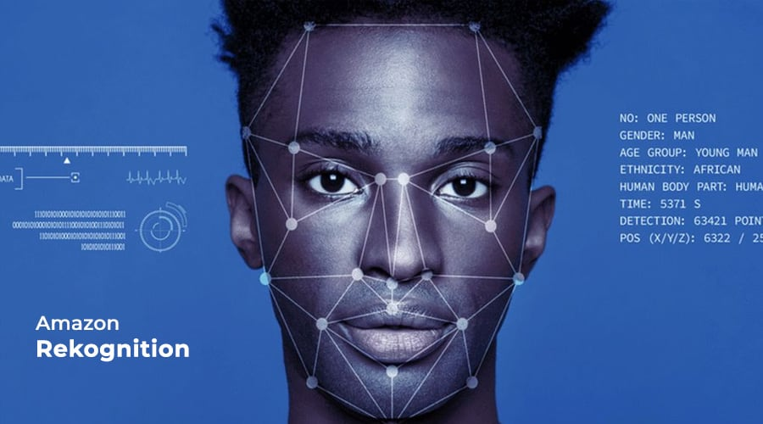

Azure -

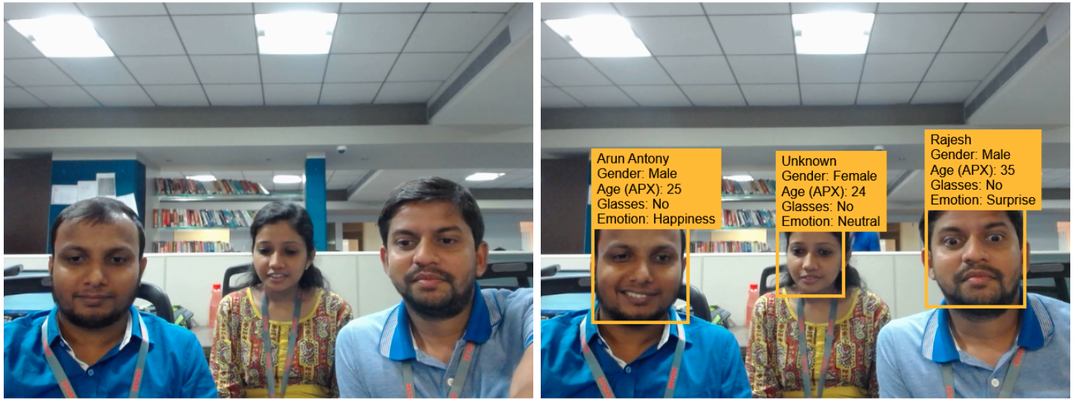

In here we need to internet connection and money. Otherwise in here you should give our face data to the cloud system.(third-party), sice the face recognition happen in their computers in the cloud.

Some application better thing is do face recognition with out data connection, with out sharing our data with anyone.

So open source Face recognition system is better choice.

**Open source Face Recognition Tools-**

This system can run locally and run your computer, without internet.

There is two –

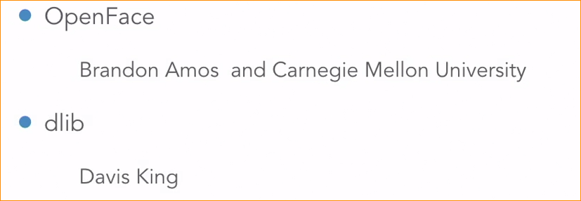

Dlib – is a general purpose machine learning and computer vision library that has lots of features.

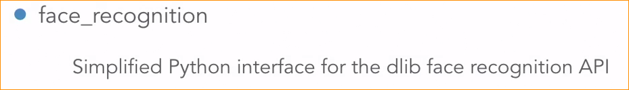

I have python library call face Recognition that makes it little easier to use Dilib.

**Face Recognize system as a Multistep Pipeline**

**Step 1 – Locate and Extract Faces**

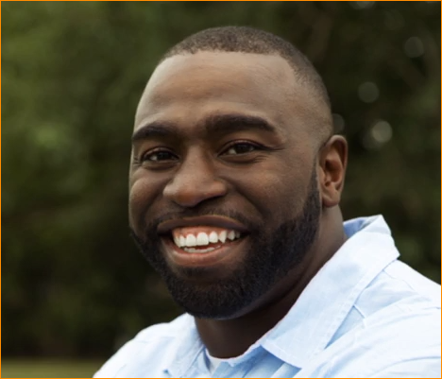in this photograph, there is a person standing in the front in the background.

We need an algorithm that can scan the image and find any faces of the appear.

I need to be able to identify this section that the area contains in the face.

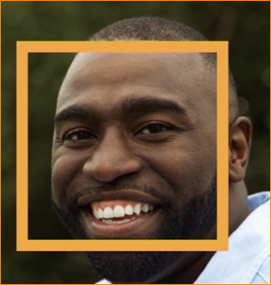

Once we know where the face located in the image, we will extract that area as a new image.

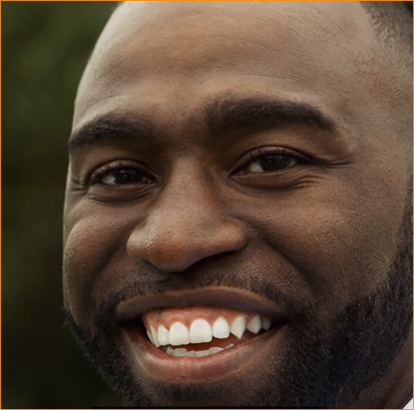this is the only pass image that pass to the next step of our face recognition pipeline.

**Step 02 – Identify facial Features**

Now we can’t compare it directly with to other face images..

To compare this face image with other faces, we need to understand how the person’s head was turned or posted when the photo was taken.

A person’s face looks different from different angles. If we don’t take the person’s head position into account, our face recognition system will think that the same person is two different people just because the person’s head was turned a different way.

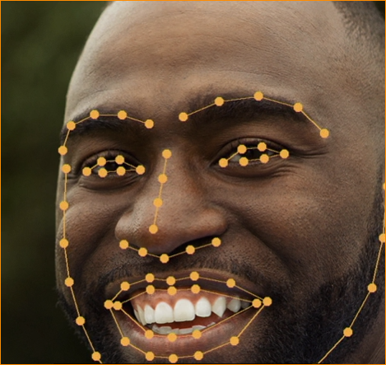

To Do this we use machine learning algorithms that can look at a single face and identify the location of each facial feature within the face.

Look the for the position of eyes, nose and mouth.

Will pass the face image and the location of each facial feature. So next step is Align faces using pose.

**Step 03 - Align faces using pose**

Try to correct for the position or pose of the person’s head.

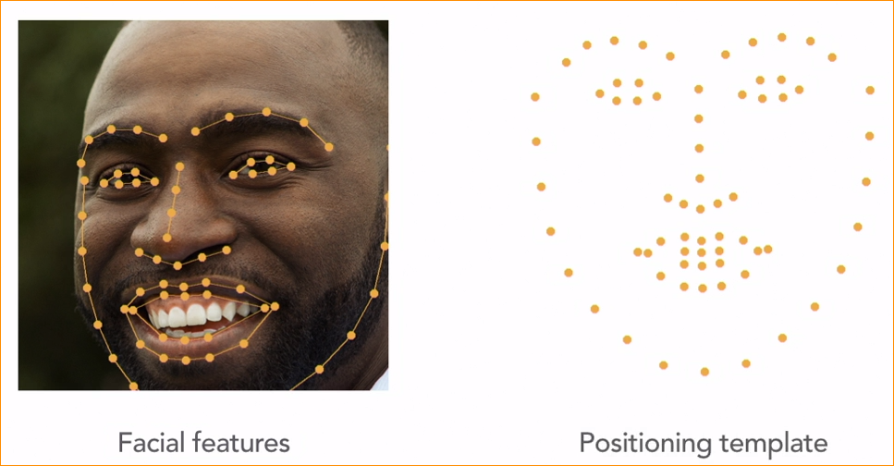

We know the position of each facial feature.

Each person’s faces is unique, but we assume that all faces follow roughly the same structure.

Right – Face position template (Show average position of facial features across lot of people, assuming that the person is looking directly forward. )

Left – with the position of each point on the template, we can guess how far the head is turned and in what direction it was turned. Then we can warp our face image roughly match the template. This is call Aligned the face.

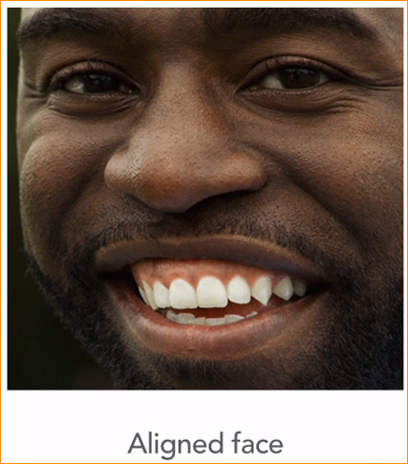Because we are making sure the key facial features In the image line up with the face template before we moving to next step in our pipe line.

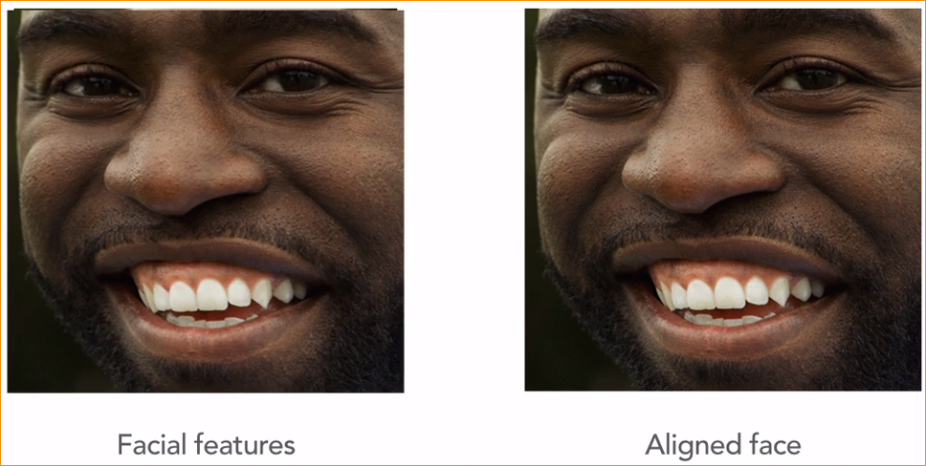

**Step 04 – Represent Face as Measurements**

We are ready to turn the face into a set of numbers or measurement that represent this unique face.

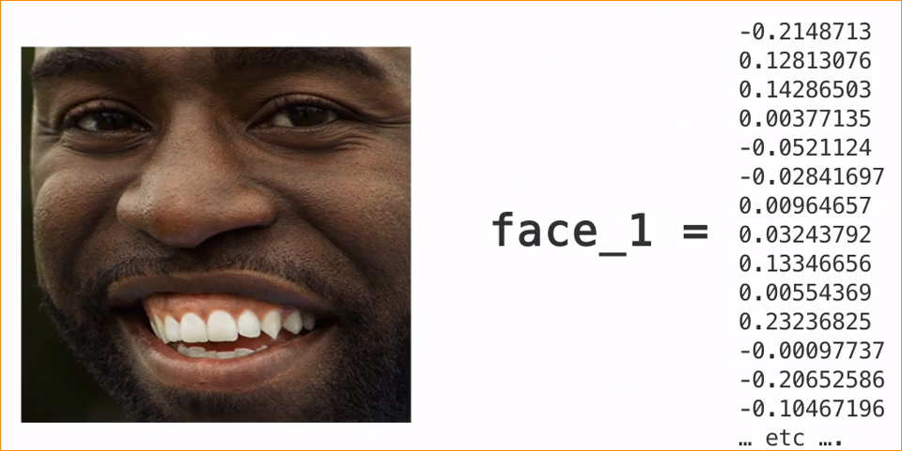

Other pictures of the same person should generate measurement that are very close to these numbers.

Pictures of a different person should generate measurement that also very different. Can imagine that we might try to measure different face characteristics, like distance between the eyes or position the eyebrows. As a way to find out what makes this face unique. Try to manually face measure that very difficult, so instead of trying to come up our own way. Using **neural network.**

That was trained on millions of faces. To come up with its own way of measuring faces.

Feed the aligned image to the neural network and it will returned a list of measurement on the right.

**Step 05 – Compare to other Faces.**

Now that we have turned the first image into a set of measurements, we compare it to other image by processing them the same way. Lets take second picture and run through the exact same face recognize pipeline.

So Neural network give measurement that relevant second image.

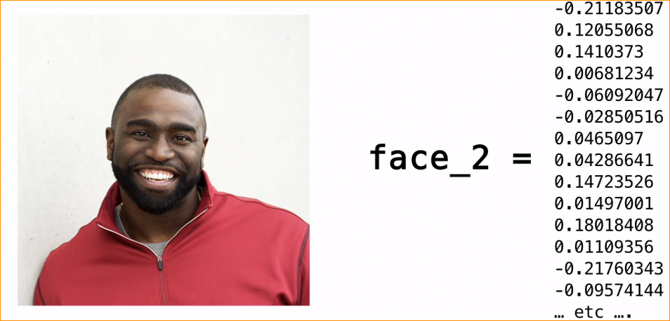

Compare to other faces

* Euclidean distance between faces.

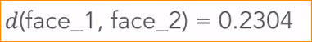

This formula basically measures how far apart the two different sets of measurements are

* In here if the measurement are close , we will call it a match

Distance rules –

< 0.6 Match !

>0.6 No Match

In this case faces are very close each other – So it match!

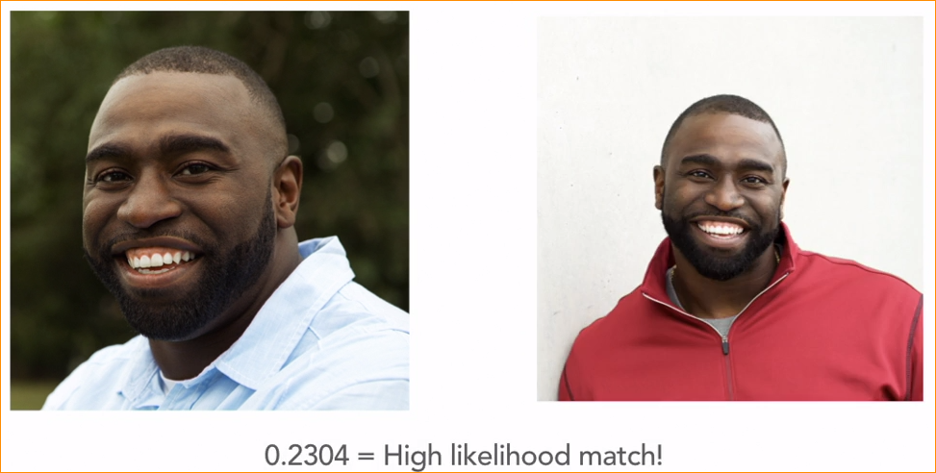

Summary of steps-

